中華大學應用統計學系

應用多變量分析
電腦實習課講義(一)

羅 琪 老師編

內容包含:

- Starting and Quitting S-PLUS

- Introduction to S+

- Matrix Algebra

- Finding mean vector, variance-covariance matrix, correlation matrix

Starting and Quitting S-PLUS

To start S-PLUS, double-click the following icon:


The S-PLUS window will appear.
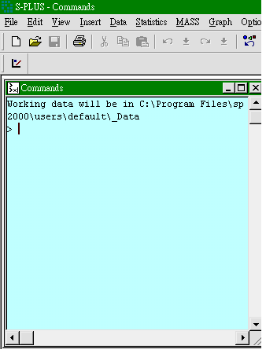在Window下選 Commands Window 可開啟指令視窗

To quit an interactive S-PLUS session, select File-Exit or type

> q()

Introduction to S+

> 3*(2+1)
[1] 9
> a_1
> a
[1] 1
> b_2
> b
[1] 2
> a+b
[1] 3
> c(1,2,5,3) # Combine Values into a Vector
- 1 2 5 3
> a_c(1,2,5,3)
> a
[1] 1 2 5 3
> a^2 # 平方
- 1 4 25 9
> summary(a) # 5-number summary
Min. 1st Qu. Median Mean 3rd Qu. Max.
1 1.75 2.5 2.75 3.5 5
> mean(a) # 平均數
[1] 2.75
> var(a) # variance 變異數
[1] 2.916667
> sqrt(var(a)) # standard deviation = square root of variance 標準差
[1] 1.707825
> min(a) # minimum value in vector 最小值
[1] 1
> max(a) # maximum value in vector最大值
[1] 5
> range(a) # (min, max)
- 1 5
> median(a) # 中位數
[1] 2.5
> length(a) # length = max(a)-min(a) 全距
- 4
> quantile(a,.75) # 75th percentile七十五百分位數
75%
3.5
> sum(a) # Sum of values in vector
[1] 11
> (a-mean(a))/sqrt(var(a)) # compute the standard scores
[1] -1.024695 -0.439155 1.317465 0.146385
> 1:10
[1] 1 2 3 4 5 6 7 8 9 10
> 10:1
[1] 10 9 8 7 6 5 4 3 2 1
> a
[1] 1 2 5 3
> d_c(2,4,
+ 3,8)
> d
[1] 2 4 3 8
> a/d
- 0.500000 0.500000 1.666667 0.375000
> a>d
[1] F F T F # F-False T-True
> a[2:4]
- 2 5 3
> a<3
[1] T T F F
> a[a<3]
[1] 1 2
> a==5
[1] F F T F
> d[a==5]
[1] 3
> a[-3] # 去掉vector第三個元素
[1] 1 2 3
> a>2
[1] F F T T
> (1:4)[a>2]
- 3 4

Matrix Algebra

> a_matrix(c(3,-1,0,-1,2,-1,0,-1,3),3,3) # create 3 by 3 matrix
> a
[,1] [,2] [,3]
[1,] 3 -1 0
[2,] -1 2 -1
[3,] 0 -1 3
> b_cbind(c(3,-2,4),c(1,3,7)) # bind together as columns
> b
[,1] [,2]
[1,] 3 1
[2,] -2 3
[3,] 4 7
> d_matrix(1:6,nrow=3,ncol=2) # create 3 by 2 matrix
> d
[,1] [,2]
[1,] 1 4
[2,] 2 5
[3,] 3 6
> a%*%b # 矩陣相乘
[,1] [,2]
[1,] 11 0
[2,] -11 -2
[3,] 14 18
> b+d # 矩陣相加
[,1] [,2]
[1,] 4 5
[2,] 0 8
[3,] 7 13
> t(b) # transpose 求轉置矩陣
[,1] [,2] [,3]
[1,] 3 -2 4
[2,] 1 3 7
> sum(diag(a)) # trace of matrix 求對角元素的和
- 8
> prod(eigen(a)$values) # compute determinant using eigenvalues 用特徵值計算行列式
- 12
> solve(a) # invert a matrix 求反矩陣
[,1] [,2] [,3]
[1,] 0.41666667 0.25 0.08333333
[2,] 0.25000000 0.75 0.25000000
[3,] 0.08333333 0.25 0.41666667
> eigen(a) # find the eigenvalues and eigenvectors of a square matrix
$values:
[1] 4 3 1

$vectors:
[,1] [,2] [,3]
[1,] 0.5773503 7.071068e-001 -0.4082483
[2,] -0.5773503 2.862294e-016 -0.8164966
[3,] 0.5773503 -7.071068e-001 -0.4082483
> p_eigen(a)
> p$vectors
[,1] [,2] [,3]
[1,] 0.5773503 7.071068e-001 -0.4082483
[2,] -0.5773503 2.862294e-016 -0.8164966
[3,] 0.5773503 -7.071068e-001 -0.4082483
> lambda_matrix(0,3,3)
> diag(lambda)_p$values
> lambda
[,1] [,2] [,3]
[1,] 4 0 0
[2,] 0 3 0
[3,] 0 0 1
> sqrta_p$vectors %*% sqrt(lambda)%*% t(p$vectors) # compute 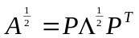
> sqrta
[,1] [,2] [,3]
[1,] 1.69935874 -0.3333333 -0.03269207
[2,] -0.33333333 1.3333333 -0.33333333
[3,] -0.03269207 -0.3333333 1.69935874
> inva_p$vectors %*% solve(lambda)%*% t(p$vectors) # compute 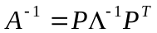
> inva
[,1] [,2] [,3]
[1,] 0.41666667 0.25 0.08333333
[2,] 0.25000000 0.75 0.25000000
[3,] 0.08333333 0.25 0.41666667
> sqrta %*% sqrta # check 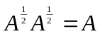
[,1] [,2] [,3]
[1,] 3.000000e+000 -1 6.661338e-016
[2,] -1.000000e+000 2 -1.000000e+000
[3,] 6.661338e-016 -1 3.000000e+000
> a %*% inva # check 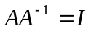
[,1] [,2] [,3]
[1,] 1.000000e+000 -1.110223e-016 0
[2,] 2.359224e-016 1.000000e+000 0
[3,] 5.551115e-017 1.110223e-016 1

Finding mean vector, variance-covariance matrix, correlation matrix

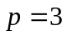 variables (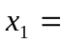assets, 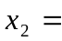 net income, 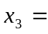 stockholder equity) for 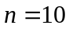 U.S. industrial corporations.
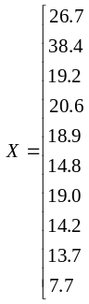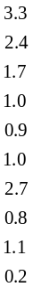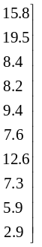
Find the sample mean vector, sample variance-covariance matrix, and sample correlation matrix. Find the generalized sample variance and the total sample variance.
File “C:\chilo\mlab\mlab1” contains the data. You can import the data by selecting File-Import Data-From Files from the S-PLUS main menu.

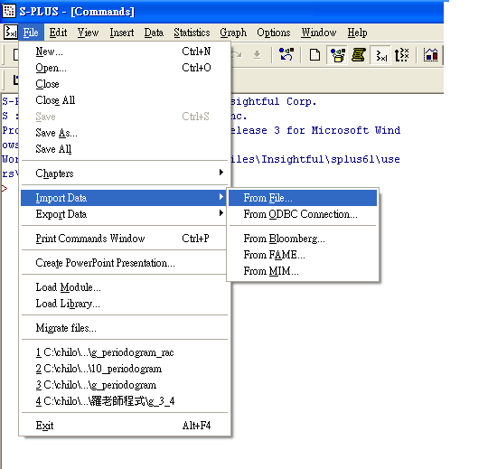
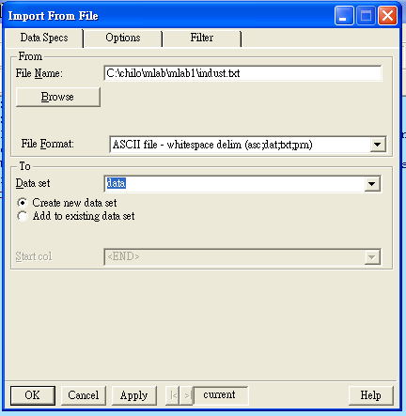

資料夾按Browse 找到檔案所放的位置,檔案名稱File Name出現C:\chilo\mlab\mlab1\indust.txt 然後按確定。在Data set內輸入data, 後再按OK。

> data
Col1 Col2 Col3
1 26.7 3.3 15.8
2 38.4 2.4 19.5
3 19.2 1.7 8.4
4 20.6 1.0 8.2
5 18.9 0.9 9.4
6 14.8 1.0 7.6
7 19.0 2.7 12.6
8 14.2 0.8 7.3
9 13.7 1.1 5.9
10 7.7 0.2 2.9
> names(data) # variable names
[1] "Col1" "Col2" "Col3"
> names(data)_c("x1","x2","x3") # change variable names to x1 x2 x3
> names(data)
[1] "x1" "x2" "x3"
> apply(data,2,mean) # compute mean vector 樣本平均向量, 2代表求行平均, 若用1代表求列平均
x1 x2 x3
19.32 1.51 9.76
> s_var(data,y=data) # compute variance-covariance matrix 樣本變異數共變數矩陣
> s
x1 x2 x3
x1 70.410667 5.8731111 39.065333
x2 5.873111 0.9698889 4.114889
x3 39.065333 4.1148889 24.056000
> cor(data,y=data) # compute correlation matrix 樣本相關係數矩陣
x1 x2 x3
x1 1.0000000 0.7107028 0.9492062
x2 0.7107028 1.0000001 0.8518938
x3 0.9492062 0.8518938 0.9999999
> prod(eigen(s)$values) # compute generalized sample variance
[1] 28.85923
> sum(diag(s)) # compute total sample variance
[1] 95.43656


