Tree-Based Models
Recursive partitioning is a fundamental tool in data mining. It helps us explore the stucture of a set of data, while developing easy to visualize decision rules for predicting a categorical (classification tree) or continuous (regression tree) outcome. This section briefly describes CART modeling, conditional inference trees, and random forests.

CART Modeling via rpart
Classification and regression trees (as described by Brieman, Freidman, Olshen, and Stone) can be generated through the rpart package. Detailed information on rpart is available in An Introduction to Recursive Partitioning Using the RPART Routines. The general steps are provided below followed by two examples.

1. Grow the Tree
To grow a tree, use
rpart(formula, data=, method=,control=) where
formula | is in the format  outcome ~ predictor1+predictor2+predictor3+ect.
data= | specifies the data frame
method= | "class" for a classification tree  "anova" for a regression tree
control= | optional parameters for controlling tree growth. For example, control=rpart.control(minsplit=30, cp=0.001) requires that the minimum number of observations in a node be 30 before attempting a split and that a split must decrease the overall lack of fit by a factor of 0.001 (cost complexity factor) before being attempted.

2. Examine the results
The following functions help us to examine the results.
printcp(fit) | display cp table
plotcp(fit) | plot cross-validation results
rsq.rpart(fit) | plot approximate R-squared and relative error for different splits (2 plots). labels are only appropriate for the "anova" method.
print(fit) | print results
summary(fit) | detailed results including surrogate splits
plot(fit) | plot decision tree
text(fit) | label the decision tree plot
post(fit,file=) | create postscript plot of decision tree
In trees created by rpart( ), move to the LEFT branch when the stated condition is true (see the graphs below).

3. prune tree
Prune back the tree to avoid overfitting the data. Typically, you will want to select a tree size that minimizes the cross-validated error, the xerror column printed by printcp( ).
Prune the tree to the desired size using
prune(fit, cp= )
Specifically, use printcp( ) to examine the cross-validated error results, select the complexity parameter associated with minimum error, and place it into the prune( ) function. Alternatively, you can use the code fragment
fit$cptable[which.min(fit$cptable[,"xerror"]),"CP"]
to automatically select the complexity parameter associated with the smallest cross-validated error. Thanks to HSAUR for this idea.

Classification Tree example 分類樹
Let's use the data frame kyphosis to predict a type of deformation (kyphosis) after surgery, from age in months (Age), number of vertebrae involved (Number), and the highest vertebrae operated on (Start).
# Classification Tree with rpart
library(rpart)

Data on Children who have had Corrective Spinal Surgery(矯正脊柱手術)

Description
The kyphosis (脊柱後凸) data frame has 81 rows and 4 columns. representing data on children who have had corrective spinal surgery
Kyphosis
a factor with levels absent present indicating if a kyphosis (a type of deformation) was present after the operation.
Age
in months
Number
the number of vertebrae involved涉及椎骨的數
Start
the number of the first (topmost) vertebra operated on. 第一個（最上面的）椎骨手術的數量。
# grow tree
fit <- rpart(Kyphosis ~ Age + Number + Start,
method="class", data=kyphosis)
printcp(fit) # display the results

Classification tree:
rpart(formula = Kyphosis ~ Age + Number + Start, data = kyphosis, method = "class")

Variables actually used in tree construction:
[1] Age Start

Root node error: 17/81 = 0.20988

n= 81
complexity param
CP nsplit rel error xerror xstd
1 0.176471 0 1.00000 1.0000 0.21559
2 0.019608 1 0.82353 1.1765 0.22829
3 0.010000 4 0.76471 1.1765 0.22829

plotcp(fit) # visualize cross-validation results
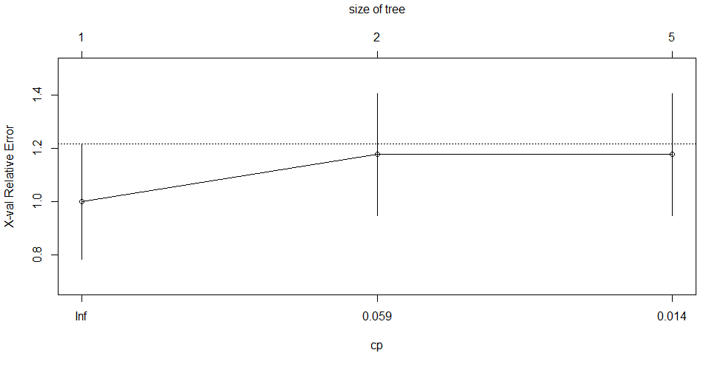
summary(fit) # detailed summary of splits
Call:
rpart(formula = Kyphosis ~ Age + Number + Start, data = kyphosis,
method = "class")
n= 81

CP nsplit rel error xerror xstd
1 0.17647059 0 1.0000000 1.000000 0.2155872
2 0.01960784 1 0.8235294 1.176471 0.2282908
3 0.01000000 4 0.7647059 1.176471 0.2282908

Variable importance
Start Age Number
64 24 12

Node number 1: 81 observations, complexity param=0.1764706
predicted class=absent expected loss=0.2098765 P(node) =1
class counts: 64 17
probabilities: 0.790 0.210
left son=2 (62 obs) right son=3 (19 obs)
Primary splits:主要分離
Start < 8.5 to the right, improve=6.762330, (0 missing)
Number < 5.5 to the left, improve=2.866795, (0 missing)
Age < 39.5 to the left, improve=2.250212, (0 missing)
Surrogate splits:替代分離
Number < 6.5 to the left, agree=0.802, adj=0.158, (0 split)

Node number 2: 62 observations, complexity param=0.01960784
predicted class=absent expected loss=0.09677419 P(node) =0.7654321=62/81
class counts: 56 6
probabilities: 0.903 0.097
left son=4 (29 obs) right son=5 (33 obs)
Primary splits:
Start < 14.5 to the right, improve=1.0205280, (0 missing)
Age < 55 to the left, improve=0.6848635, (0 missing)
Number < 4.5 to the left, improve=0.2975332, (0 missing)
Surrogate splits:
Number < 3.5 to the left, agree=0.645, adj=0.241, (0 split)
Age < 16 to the left, agree=0.597, adj=0.138, (0 split)

Node number 3: 19 observations
predicted class=present expected loss=0.4210526 P(node) =0.2345679=19/81
class counts: 8 11
probabilities: 0.421 0.579

Node number 4: 29 observations
predicted class=absent expected loss=0 P(node) =0.3580247
class counts: 29 0
probabilities: 1.000 0.000

Node number 5: 33 observations, complexity param=0.01960784
predicted class=absent expected loss=0.1818182 P(node) =0.4074074
class counts: 27 6
probabilities: 0.818 0.182
left son=10 (12 obs) right son=11 (21 obs)
Primary splits:
Age < 55 to the left, improve=1.2467530, (0 missing)
Start < 12.5 to the right, improve=0.2887701, (0 missing)
Number < 3.5 to the right, improve=0.1753247, (0 missing)
Surrogate splits:
Start < 9.5 to the left, agree=0.758, adj=0.333, (0 split)
Number < 5.5 to the right, agree=0.697, adj=0.167, (0 split)

Node number 10: 12 observations
predicted class=absent expected loss=0 P(node) =0.1481481
class counts: 12 0
probabilities: 1.000 0.000

Node number 11: 21 observations, complexity param=0.01960784
predicted class=absent expected loss=0.2857143 P(node) =0.2592593
class counts: 15 6
probabilities: 0.714 0.286
left son=22 (14 obs) right son=23 (7 obs)
Primary splits:
Age < 111 to the right, improve=1.71428600, (0 missing)
Start < 12.5 to the right, improve=0.79365080, (0 missing)
Number < 3.5 to the right, improve=0.07142857, (0 missing)

Node number 22: 14 observations
predicted class=absent expected loss=0.1428571 P(node) =0.1728395
class counts: 12 2
probabilities: 0.857 0.143

Node number 23: 7 observations
predicted class=present expected loss=0.4285714 P(node) =0.08641975
class counts: 3 4
probabilities: 0.429 0.571
# plot tree
plot(fit, uniform=TRUE,
main="Classification Tree for Kyphosis")
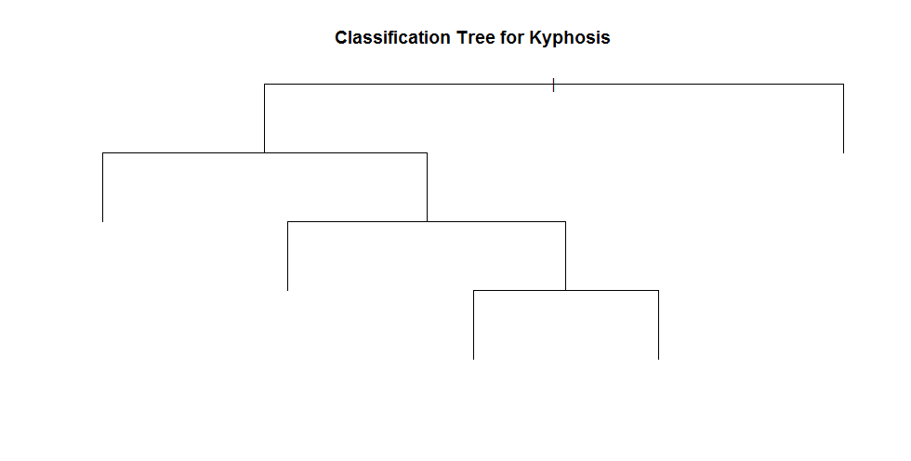
text(fit, use.n=TRUE, all=TRUE, cex=.8)
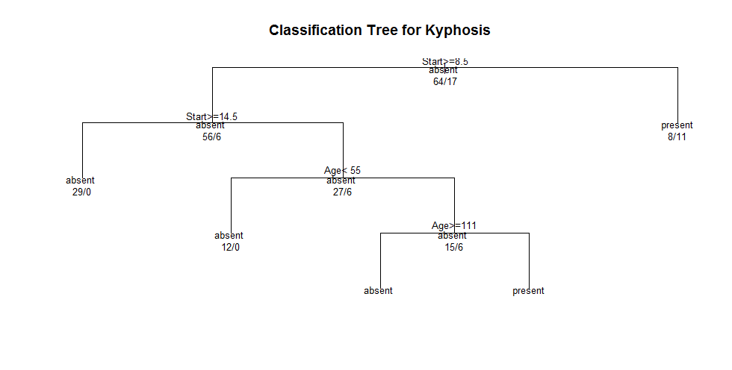
# create attractive postscript plot of tree
post(fit, file = "c:/tree.ps",
title = "Classification Tree for Kyphosis")
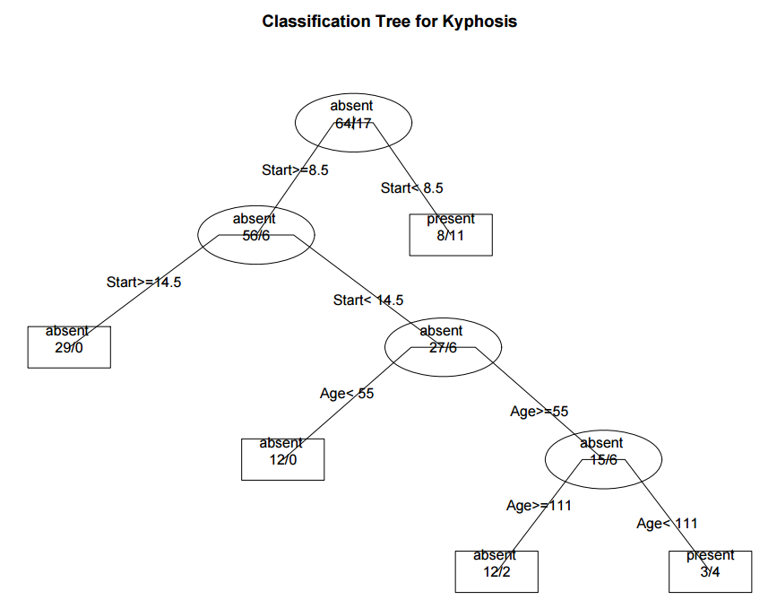
# prune the tree
pfit<-prune(fit, cp=fit$cptable[which.min(fit$cptable[,"xerror"]),"CP"])
# plot the pruned tree
plot(pfit, uniform=TRUE,
main="Pruned Classification Tree for Kyphosis")
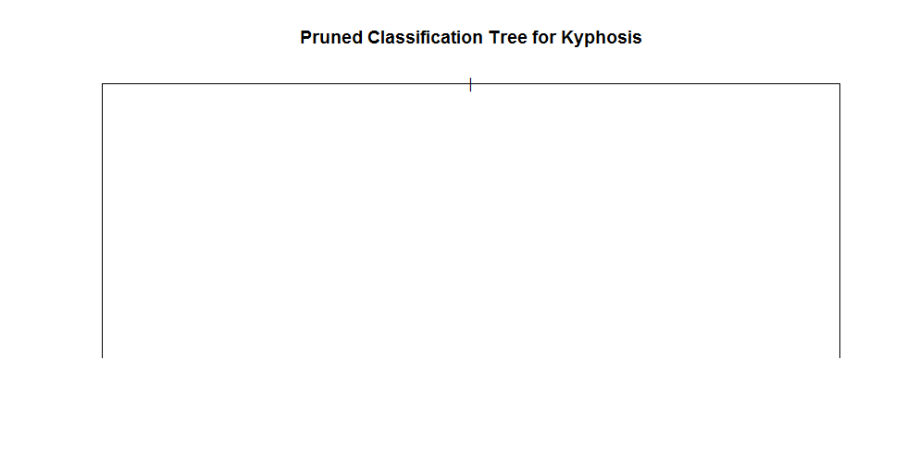
text(pfit, use.n=TRUE, all=TRUE, cex=.8)
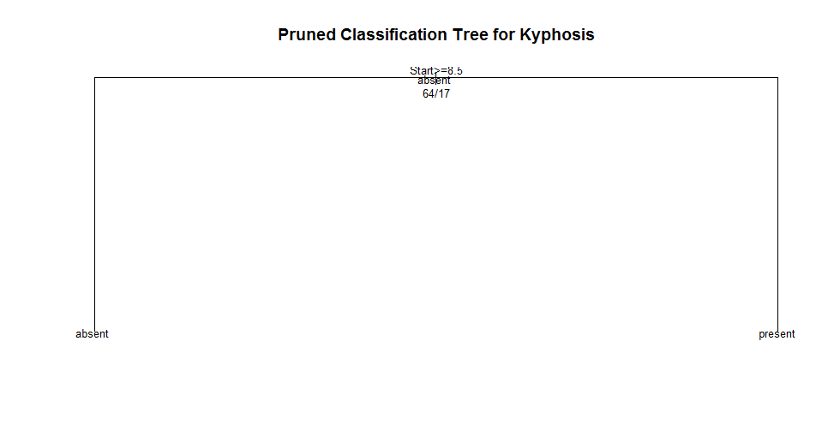
post(pfit, file = "c:/ptree.ps",
title = "Pruned Classification Tree for Kyphosis")
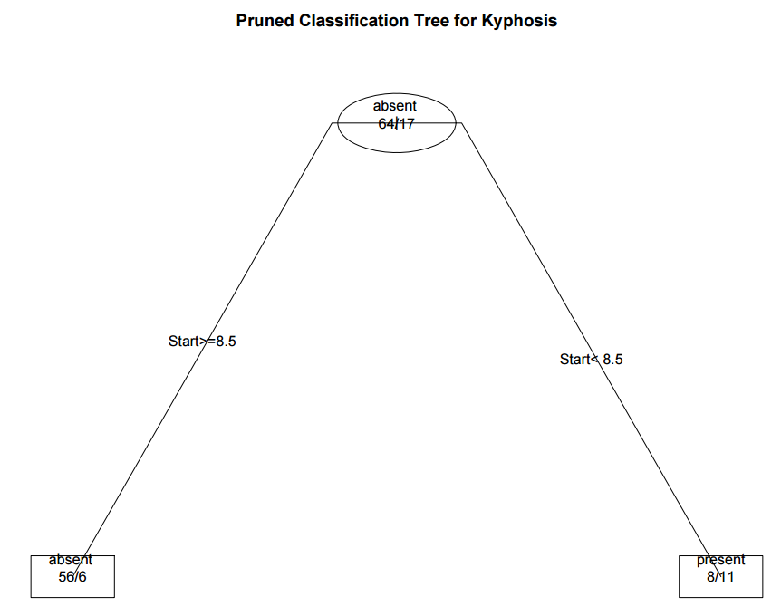

Regression Tree example 迴歸樹
In this example we will predict car mileage from price, country, reliability, and car type. The data frame is cu.summary.
# Regression Tree Example
library(rpart)

Automobile Data from 'Consumer Reports' 1990

Description
The cu.summary data frame has 117 rows and 5 columns, giving data on makes of cars taken from the April, 1990 issue of Consumer Reports.
Price價格
a numeric vector giving the list price in US dollars of a standard model
Country國家
of origin, a factor with levels
Brazil, England, France, Germany, Japan, Japan/USA, Korea, Mexico, Sweden and USA
Reliability可靠性
an ordered factor with levels
Much worse < worse < average < better < Much better
Mileage里程
fuel consumption miles per US gallon, as tested.
Type
a factor with levels
Compact Large Medium Small Sporty Van
# grow tree
fit <- rpart(Mileage~Price + Country + Reliability + Type,
method="anova", data=cu.summary)
printcp(fit) # display the results

Regression tree:
rpart(formula = Mileage ~ Price + Country + Reliability + Type,
data = cu.summary, method = "anova")

Variables actually used in tree construction:
[1] Price Type

Root node error: 1354.6/60 = 22.576

n=60 (57 observations deleted due to missingness)

CP nsplit rel error xerror xstd
1 0.622885 0 1.00000 1.05589 0.180484
2 0.132061 1 0.37711 0.52725 0.101277
3 0.025441 2 0.24505 0.41337 0.082812
4 0.011604 3 0.21961 0.39568 0.081798
5 0.010000 4 0.20801 0.43176 0.085924
plotcp(fit) # visualize cross-validation results
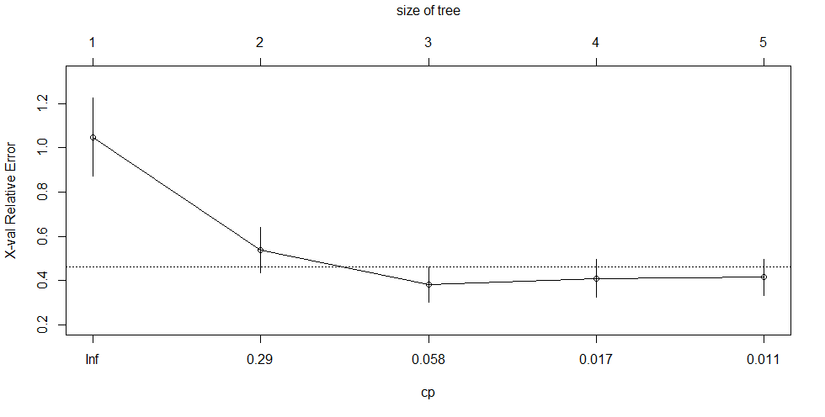
summary(fit) # detailed summary of splits
Call:
rpart(formula = Mileage ~ Price + Country + Reliability + Type,
data = cu.summary, method = "anova")
n=60 (57 observations deleted due to missingness)

CP nsplit rel error xerror xstd
1 0.62288527 0 1.0000000 1.0558894 0.18048384
2 0.13206061 1 0.3771147 0.5272510 0.10127688
3 0.02544094 2 0.2450541 0.4133746 0.08281166
4 0.01160389 3 0.2196132 0.3956805 0.08179847
5 0.01000000 4 0.2080093 0.4317620 0.08592369

Variable importance
Price Type Country
48 42 10

Node number 1: 60 observations, complexity param=0.6228853
mean=24.58333, MSE=22.57639
left son=2 (48 obs) right son=3 (12 obs)
Primary splits:
Price < 9446.5 to the right, improve=0.6228853, (0 missing)
Type splits as LLLRLL, improve=0.5044405, (0 missing)
Reliability splits as LLLRR, improve=0.1263005, (11 missing)
Country splits as --LRLRRRLL, improve=0.1243525, (0 missing)
Surrogate splits:
Type splits as LLLRLL, agree=0.950, adj=0.750, (0 split)
Country splits as --LLLLRRLL, agree=0.833, adj=0.167, (0 split)

Node number 2: 48 observations, complexity param=0.1320606
mean=22.70833, MSE=8.498264
left son=4 (23 obs) right son=5 (25 obs)
Primary splits:
Type splits as RLLRRL, improve=0.43853830, (0 missing)
Price < 12154.5 to the right, improve=0.25748500, (0 missing)
Country splits as --RRLRL-LL, improve=0.13345700, (0 missing)
Reliability splits as LLLRR, improve=0.01637086, (10 missing)
Surrogate splits:
Price < 12215.5 to the right, agree=0.812, adj=0.609, (0 split)
Country splits as --RRLRL-RL, agree=0.646, adj=0.261, (0 split)

Node number 3: 12 observations
mean=32.08333, MSE=8.576389

Node number 4: 23 observations, complexity param=0.02544094
mean=20.69565, MSE=2.907372
left son=8 (10 obs) right son=9 (13 obs)
Primary splits:
Type splits as -LR--L, improve=0.515359600, (0 missing)
Price < 14962 to the left, improve=0.131259400, (0 missing)
Country splits as ----L-R--R, improve=0.007022107, (0 missing)
Surrogate splits:
Price < 13572 to the right, agree=0.609, adj=0.1, (0 split)

Node number 5: 25 observations, complexity param=0.01160389
mean=24.56, MSE=6.4864
left son=10 (14 obs) right son=11 (11 obs)
Primary splits:
Price < 11484.5 to the right, improve=0.09693168, (0 missing)
Reliability splits as LLRRR, improve=0.07767167, (4 missing)
Type splits as L--RR-, improve=0.04209834, (0 missing)
Country splits as --LRRR--LL, improve=0.02201687, (0 missing)
Surrogate splits:
Country splits as --LLLL--LR, agree=0.80, adj=0.545, (0 split)
Type splits as L--RL-, agree=0.64, adj=0.182, (0 split)

Node number 8: 10 observations
mean=19.3, MSE=2.21

Node number 9: 13 observations
mean=21.76923, MSE=0.7928994

Node number 10: 14 observations
mean=23.85714, MSE=7.693878

Node number 11: 11 observations
mean=25.45455, MSE=3.520661

# create additional plots
par(mfrow=c(1,2)) # two plots on one page
rsq.rpart(fit) # visualize cross-validation results
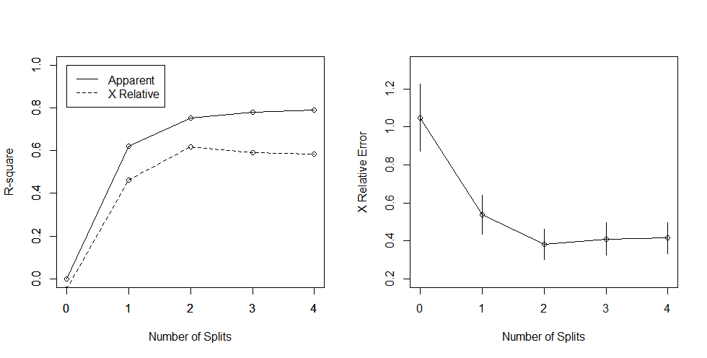
# plot tree
plot(fit, uniform=TRUE,
main="Regression Tree for Mileage ")
text(fit, use.n=TRUE, all=TRUE, cex=.8)
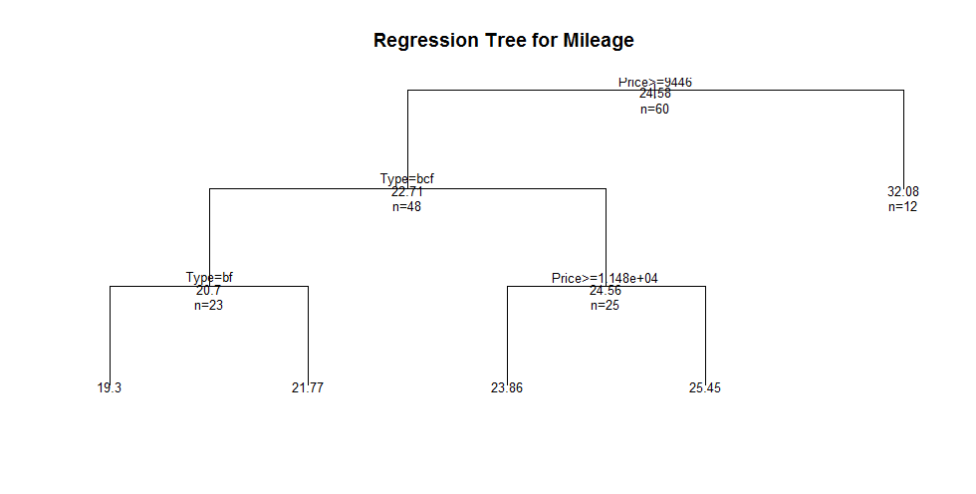
# create attractive postcript plot of tree
post(fit, file = "c:/tree2.ps",
title = "Regression Tree for Mileage ")
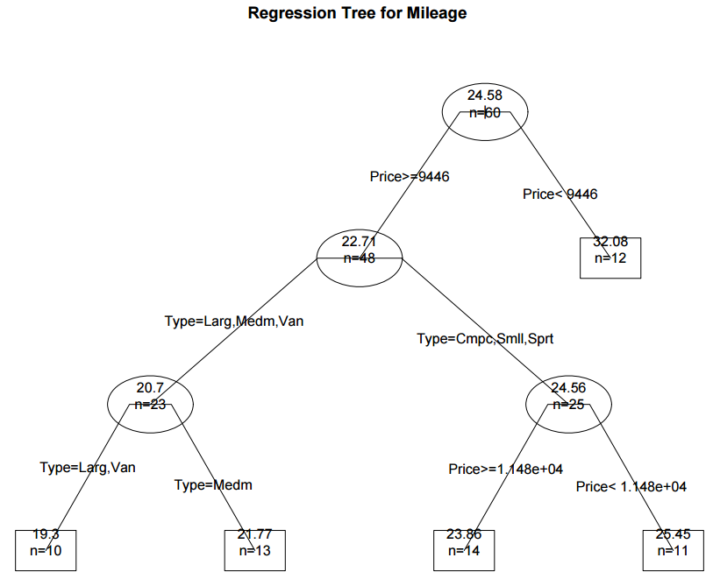

# prune the tree
pfit<- prune(fit, cp=0.01160389) # from cptable
# plot the pruned tree
plot(pfit, uniform=TRUE,
main="Pruned Regression Tree for Mileage")
text(pfit, use.n=TRUE, all=TRUE, cex=.8)
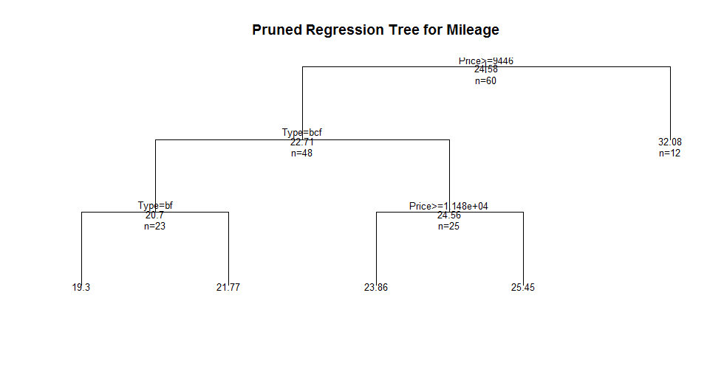
post(pfit, file = "c:/ptree2.ps",
title = "Pruned Regression Tree for Mileage")
It turns out that this produces the same tree as the original.

Conditional inference trees via party
The party package provides nonparametric regression trees for nominal, ordinal, numeric, censored, and multivariate responses. party: A laboratory for recursive partitioning, provides details.
You can create a regression or classification tree via the function
ctree(formula, data=)
The type of tree created will depend on the outcome variable (nominal factor, ordered factor, numeric, etc.). Tree growth is based on statistical stopping rules, so pruning should not be required.
The previous two examples are re-analyzed below.

# Conditional Inference Tree for Kyphosis
library(party)
fit <- ctree(Kyphosis ~ Age + Number + Start,
data=kyphosis)
plot(fit, main="Conditional Inference Tree for Kyphosis")
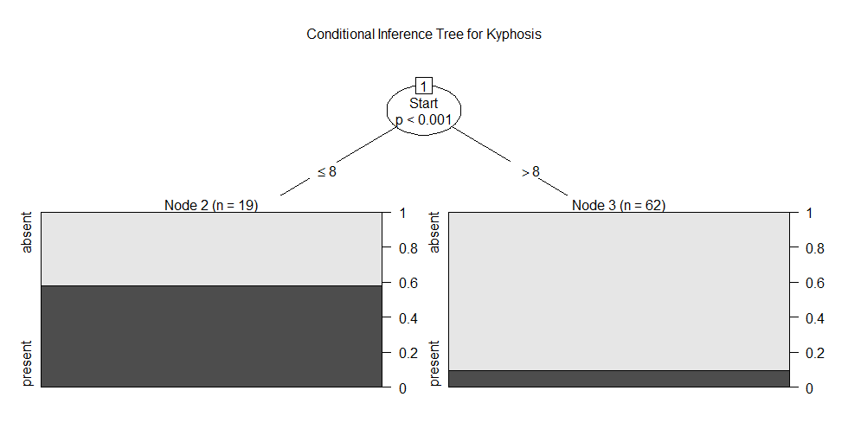
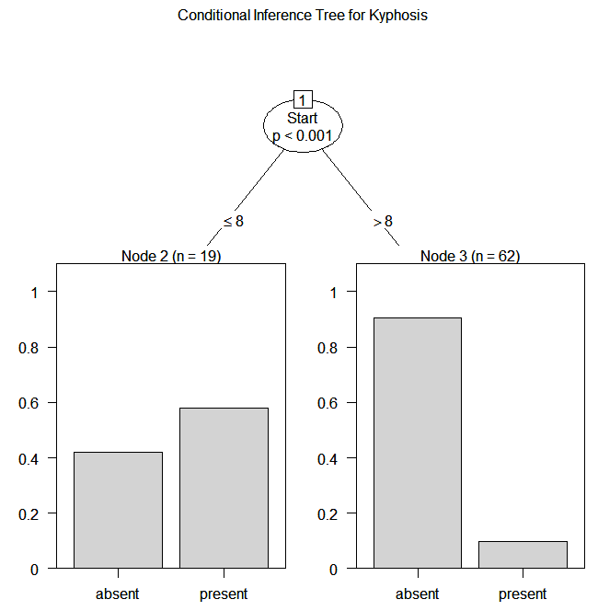

# Conditional Inference Tree for Mileage
library(party)
fit2 <- ctree(Mileage~Price + Country + Reliability + Type,
data=na.omit(cu.summary))
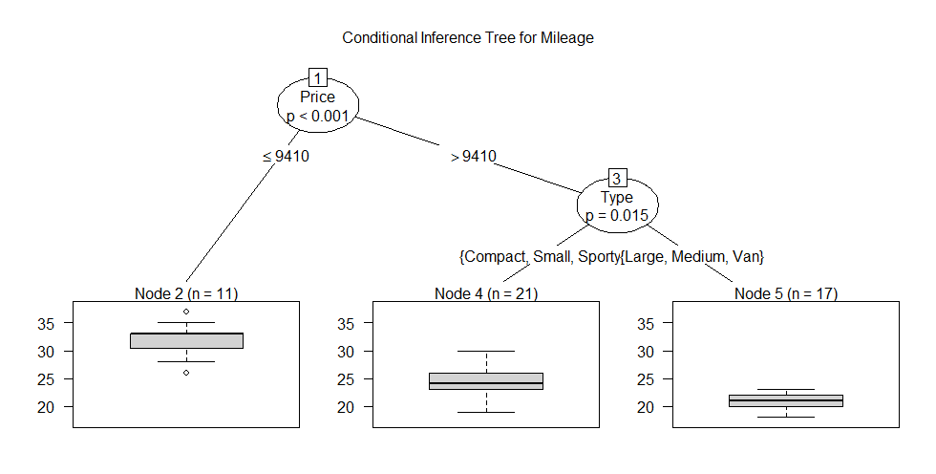

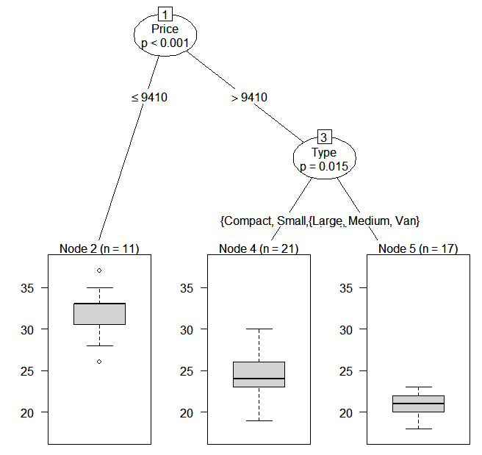

Conditional Inference Trees

Conditional inference trees estimate a regression relationship by binary recursive partitioning in a conditional inference framework. Roughly, the algorithm works as follows:

1) Test the global null hypothesis of independence between any of the input variables and the response (which may be multivariate as well). Stop if this hypothesis cannot be rejected. Otherwise select the input variable with strongest association to the response. This association is measured by a p-value corresponding to a test for the partial null hypothesis of a single input variable and the response.

2) Implement a binary split in the selected input variable.

3) Recursively repeats steps 1) and 2).

Random Forests
Random forests improve predictive accuracy by generating a large number of bootstrapped trees (based on random samples of variables), classifying a case using each tree in this new "forest", and deciding a final predicted outcome by combining the results across all of the trees (an average in regression, a majority vote in classification). Breiman and Cutler's random forest approach is implimented via therandomForest package.
Here is an example.
# Random Forest prediction of Kyphosis data
library(randomForest)
fit <- randomForest(Kyphosis ~ Age + Number + Start, data=kyphosis)
print(fit) # view results
importance(fit) # importance of each predictor
For more details see the comprehensive Random Forest website.

Going Further
This section has only touched on the options available. To learn more, see the CRAN Task View onMachine & Statistical Learning.

