http://www.r-bloggers.com/a-brief-tour-of-the-trees-and-forests/

A Brief Tour of the Trees and Forests
April 29, 2013
By Wesley
inShare1
(This article was first published on Statistical Research » R, and kindly contributed to R-bloggers)
Tree methods such as CART (classification and regression trees) can be used as alternatives to logistic regression. It is a way that can be used to show the probability of being in any hierarchical group. The following is a compilation of many of the key R packages that cover trees and forests. The goal here is to simply give some brief examples on a few approaches on growing trees and, in particular, the visualization of the trees. These packages include classification and regression trees, graphing and visualization, ensemble learning using random forests, as well as evolutionary learning trees. There are a wide array of package in R that handle decision trees including trees for longitudinal studies. I have found that when using several combinations of these packages simultaneously that some of the function begin to fail to work.
The concept of trees and forests can be applied in many different setting and is often seen in machine learning and data mining settings or other settings where there is a significant amount of data. The examples below are by no means comprehensive and exhaustive. However, there are several examples given using different datasets and a variety of R packages. The first example uses some data obtain from the Harvard Dataverse Network. For reference the data can be obtain from http://dvn.iq.harvard.edu/dvn/. The study was recently released on April 22nd, 2013 and the raw data as well as the documentation is available on the Dataverse web site and the study ID is hdl:1902.1/21235. The other examples use data that are shipped with the R packages.
rpart
This package includes several example sets of data that can be used for recursive partitioning and regression trees. Categorical or continuous variables can be used depending on whether one wants classification trees or regression trees. This package as well at the tree package are probably the two go-to packages for trees. However, care should be taken as the tree package and the rpart package can produce very different results.
library(rpart)
raw.orig <-read.csv(file="c:\\rsei212_chemical.txt", header=T, sep="\t")

# Keep the dataset small and tidy
# The Dataverse: hdl:1902.1/21235
raw = subset(raw.orig, select=c("Metal","OTW","AirDecay","Koc"))

row.names(raw) = raw.orig$CASNumber
raw = na.omit(raw);

frmla = Metal ~ OTW + AirDecay + Koc

# Metal: Core Metal (CM); Metal (M); Non-Metal (NM); Core Non-Metal (CNM)

fit = rpart(frmla, method="class", data=raw)

printcp(fit) # display the results

Classification tree:
rpart(formula = frmla, data = raw, method = "class")

Variables actually used in tree construction:
[1] AirDecay Koc OTW

Root node error: 172/352 = 0.48864

n= 352

CP nsplit rel error xerror xstd
1 0.279070 0 1.00000 1.12209 0.054285
2 0.069767 1 0.72093 0.79070 0.053112
3 0.029070 2 0.65116 0.75581 0.052644
4 0.017442 3 0.62209 0.76744 0.052808
5 0.011628 4 0.60465 0.78488 0.053039
6 0.010000 5 0.59302 0.77907 0.052964

plotcp(fit) # visualize cross-validation results
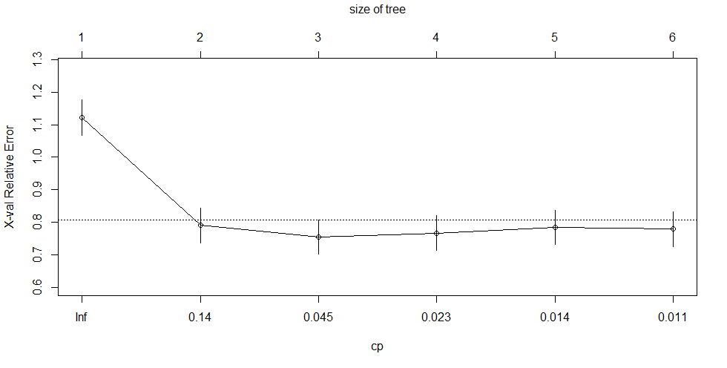
summary(fit) # detailed summary of splits

Call:
rpart(formula = frmla, data = raw, method = "class")
n= 352

CP nsplit rel error xerror xstd
1 0.27906977 0 1.0000000 1.1220930 0.05428470
2 0.06976744 1 0.7209302 0.7906977 0.05311248
3 0.02906977 2 0.6511628 0.7558140 0.05264394
4 0.01744186 3 0.6220930 0.7674419 0.05280786
5 0.01162791 4 0.6046512 0.7848837 0.05303920
6 0.01000000 5 0.5930233 0.7790698 0.05296401

Variable importance
Koc AirDecay OTW
45 34 21

Node number 1: 352 observations, complexity param=0.2790698
predicted class=CNM expected loss=0.4886364 P(node) =1
class counts: 5 180 3 164
probabilities: 0.014 0.511 0.009 0.466
left son=2 (177 obs) right son=3 (175 obs)
Primary splits:
Koc < 190.5 to the left, improve=17.891350, (0 missing)
AirDecay < 0.0266 to the left, improve= 9.972175, (0 missing)
OTW < 3.1 to the left, improve= 3.928582, (0 missing)
Surrogate splits:
AirDecay < 0.03495 to the left, agree=0.605, adj=0.206, (0 split)
OTW < 87.5 to the right, agree=0.574, adj=0.143, (0 split)

Node number 2: 177 observations
predicted class=CNM expected loss=0.3333333 P(node) =0.5028409
class counts: 5 118 0 54
probabilities: 0.028 0.667 0.000 0.305

Node number 3: 175 observations, complexity param=0.06976744
predicted class=NM expected loss=0.3714286 P(node) =0.4971591
class counts: 0 62 3 110
probabilities: 0.000 0.354 0.017 0.629
left son=6 (34 obs) right son=7 (141 obs)
Primary splits:
AirDecay < 0.005825 to the left, improve=8.319349, (0 missing)
OTW < 12.5 to the left, improve=5.497489, (0 missing)
Koc < 2500 to the left, improve=3.099420, (0 missing)

Node number 6: 34 observations, complexity param=0.01162791
predicted class=CNM expected loss=0.3235294 P(node) =0.09659091
class counts: 0 23 0 11
probabilities: 0.000 0.676 0.000 0.324
left son=12 (20 obs) right son=13 (14 obs)
Primary splits:
AirDecay < 0.000574 to the right, improve=2.925210, (0 missing)
OTW < 480 to the left, improve=2.165686, (0 missing)
Koc < 3600 to the left, improve=1.083411, (0 missing)
Surrogate splits:
Koc < 4900 to the left, agree=0.706, adj=0.286, (0 split)
OTW < 3.65 to the right, agree=0.647, adj=0.143, (0 split)

Node number 7: 141 observations, complexity param=0.02906977
predicted class=NM expected loss=0.2978723 P(node) =0.4005682
class counts: 0 39 3 99
probabilities: 0.000 0.277 0.021 0.702
left son=14 (29 obs) right son=15 (112 obs)
Primary splits:
OTW < 12.5 to the left, improve=6.551475, (0 missing)
Koc < 1250 to the left, improve=2.542887, (0 missing)
AirDecay < 0.2175 to the right, improve=1.717422, (0 missing)

Node number 12: 20 observations
predicted class=CNM expected loss=0.15 P(node) =0.05681818
class counts: 0 17 0 3
probabilities: 0.000 0.850 0.000 0.150

Node number 13: 14 observations
predicted class=NM expected loss=0.4285714 P(node) =0.03977273
class counts: 0 6 0 8
probabilities: 0.000 0.429 0.000 0.571

Node number 14: 29 observations, complexity param=0.01744186
predicted class=CNM expected loss=0.4137931 P(node) =0.08238636
class counts: 0 17 0 12
probabilities: 0.000 0.586 0.000 0.414
left son=28 (20 obs) right son=29 (9 obs)
Primary splits:
Koc < 1250 to the left, improve=1.6689660, (0 missing)
OTW < 9.4 to the right, improve=1.3546800, (0 missing)
AirDecay < 0.04055 to the left, improve=0.3952813, (0 missing)
Surrogate splits:
AirDecay < 0.5575 to the left, agree=0.759, adj=0.222, (0 split)

Node number 15: 112 observations
predicted class=NM expected loss=0.2232143 P(node) =0.3181818
class counts: 0 22 3 87
probabilities: 0.000 0.196 0.027 0.777

Node number 28: 20 observations
predicted class=CNM expected loss=0.3 P(node) =0.05681818
class counts: 0 14 0 6
probabilities: 0.000 0.700 0.000 0.300

Node number 29: 9 observations
predicted class=NM expected loss=0.3333333 P(node) =0.02556818
class counts: 0 3 0 6
probabilities: 0.000 0.333 0.000 0.667

# plot tree
plot(fit, uniform=TRUE, main="Classification Tree for Chemicals")
text(fit, use.n=TRUE, all=TRUE, cex=.8)
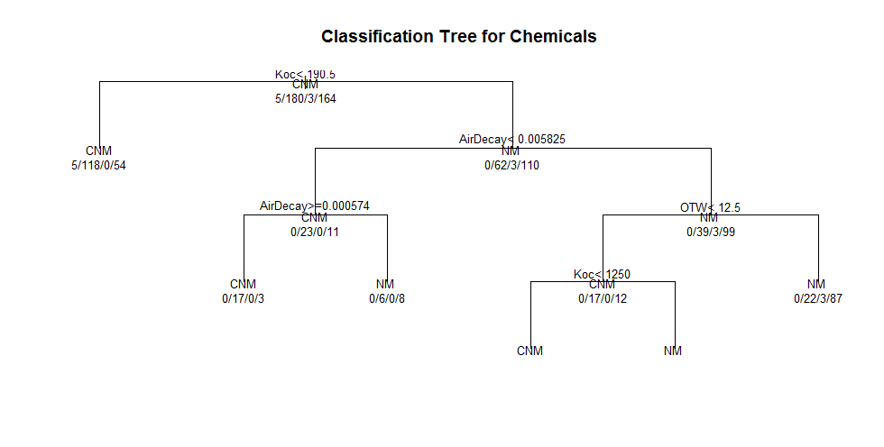

# tabulate some of the data
table(subset(raw, Koc>=190.5)$Metal)
CM CNM M NM
0 62 3 110

tree
This is the primary R package for classification and regression trees. It has functions to prune the tree as well as general plotting functions and the mis-classifications (total loss). The output from tree can be easier to compare to the General Linear Model (GLM) and General Additive Model (GAM) alternatives.
###############
# TREE package
install.packages("tree")
library(tree)

tr = tree(frmla, data=raw)
summary(tr)

Classification tree:
tree(formula = frmla, data = raw)
Number of terminal nodes: 12
Residual mean deviance: 1.186 = 403.3 / 340
Misclassification error rate: 0.2812 = 99 / 352

plot(tr); text(tr) 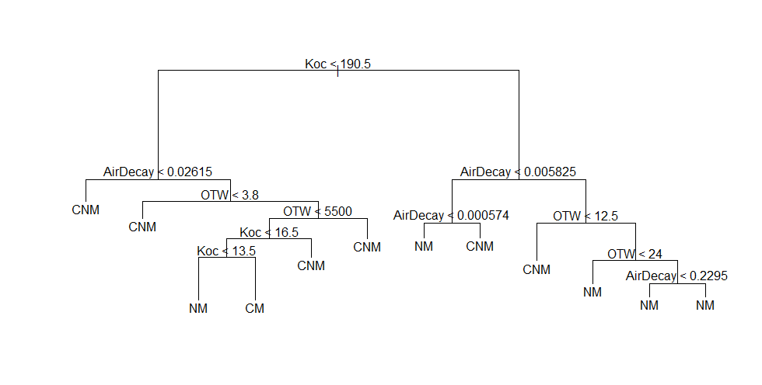
party
This is another package for recursive partitioning. One of the key functions in this package is ctree. As the package documention indicates it can be used for continuous, censored, ordered, nominal and multivariate response variable in a conditional inference framework. The party package also implements recursive partitioning for survival data.
###############
# PARTY package
install.packages("party")
library(party)

ct = ctree(frmla, data = raw))
plot(ct, main="Conditional Inference Tree")
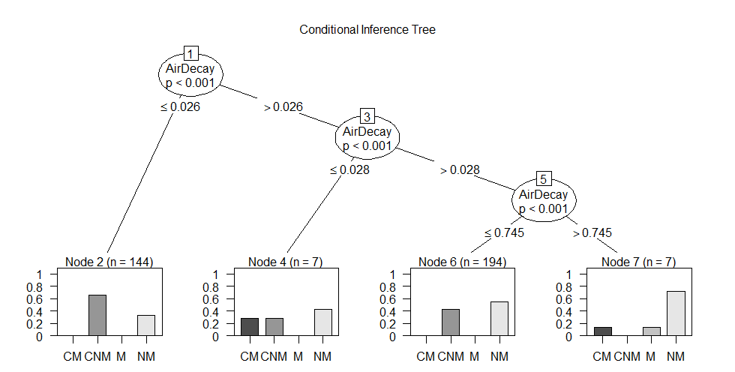
#Table of prediction errors
table(predict(ct), raw$Metal)
CM CNM M NM
CM 0 0 0 0
CNM 0 95 1 48
M 0 0 0 0
NM 5 85 2 116

# Estimated class probabilities
tr.pred = predict(ct, newdata=raw, type="prob")
maptree
maptree is a very good at graphing, pruning data from hierarchical clustering, and CART models. The trees produced by this package tend to be better labeled and higher quality and the stock plots from rpart.

partykit
This contains a re-implementation of the ctree function and it provides some very good graphing and visualization for tree models. It is similar to the party package. The example below uses data from airquality dataset and the famous species data available in R and can be found in the documentation.
1 | <a href="http://statistical-research.com/wp-content/uploads/2012/12/species.png"><img alt="Species Decision Tree" src="http://statistical-research.com/wp-content/uploads/2012/12/species.png" width="437" height="472" /></a> <a href="http://statistical-research.com/wp-content/uploads/2012/12/airqualityOzone.png"><img alt="Ozone Air Quality Decision Tree" src="http://statistical-research.com/wp-content/uploads/2012/12/airqualityOzone.png" width="437" height="472" /></a>
evtree
This package uses evolutionary algorithms. The idea behind this approach is that is will reduce the a priori bias. I have seen trees of this sort in the area of environmental research, bioinformatics, systematics, and marine biology. Though there are many other areas than that of phylogentics.
###############
## EVTREE (Evoluationary Learning)
library(evtree)

ev.raw = evtree(frmla, data=raw)
plot(ev.raw)
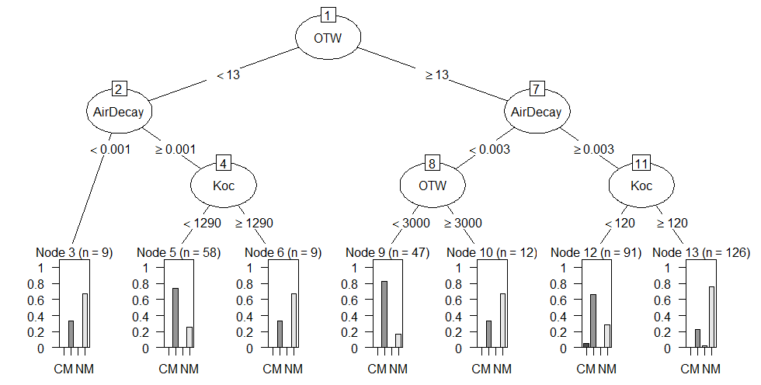
table(predict(ev.raw), raw$Metal)

CM CNM M NM
CM 0 0 0 0
CNM 5 142 0 49
M 0 0 0 0
NM 0 38 3 115

1-mean(predict(ev.raw) == raw$Metal)

randomForest
Random forests are very good in that it is an ensemble learning method used for classification and regression. It uses multiple models for better performance that just using a single tree model. In addition because many sample are selected in the process a measure of variable importance can be obtain and this approach can be used for model selection and can be particularly useful when forward/backward stepwise selection is not appropriate and when working with an extremely high number of candidate variables that need to be reduced.
 | 1  2  3  4  5  6  7  8  9  10  11  12  13  14  15  16  17 |  | ##################  ## randomForest  library(randomForest)  fit.rf = randomForest(frmla, data=raw)  print(fit.rf)  importance(fit.rf)  plot(fit.rf)  plot( importance(fit.rf), lty=2, pch=16)  lines(importance(fit.rf))  imp = importance(fit.rf)  impvar = rownames(imp)[order(imp[, 1], decreasing=TRUE)]  op = par(mfrow=c(1, 3))  for (i in seq_along(impvar)) {  partialPlot(fit.rf, raw, impvar[i], xlab=impvar[i],  main=paste("Partial Dependence on", impvar[i]),  ylim=c(0, 1))  }
 |  | >importance(rf1)
 |  | %IncMSE |  | IncNodePurity
x1 |  | 30.30146 |  | 8657.963
x2 |  | 7.739163 |  | 3675.853
x3 |  | 0.586905 |  | 240.275
x4 |  | -0.82209 |  | 381.6304
x5 |  | 0.583622 |  | 253.3885
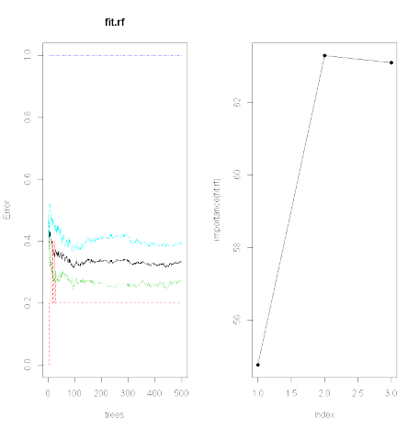
varSelRF
This can be used for further variable selection procedure using random forests. It implements both backward stepwise elimination as well as selection based on the importance spectrum. This data uses randomly generated data so the correlation matrix can set so that the first variable is strongly correlated and the other variables are less so.
1  2  3  4  5  6  7  8  9  10  11  12  13  14  15  16  17  18  19  20  21 | ##################  ## varSelRF package  library(varSelRF)  x = matrix(rnorm(25 * 30), ncol = 30)  x[1:10, 1:2] = x[1:10, 1:2] + 2  cl = factor(c(rep("A", 10), rep("B", 15)))  rf.vs1 = varSelRF(x, cl, ntree = 200, ntreeIterat = 100,  vars.drop.frac = 0.2)  rf.vs1  plot(rf.vs1)  ## Example of importance function show that forcing x1 to be the most important  ## while create secondary variables that is related to x1.  x1=rnorm(500)  x2=rnorm(500,x1,1)  y=runif(1,1,10)*x1+rnorm(500,0,.5)  my.df=data.frame(y,x1,x2,x3=rnorm(500),x4=rnorm(500),x5=rnorm(500))  rf1 = randomForest(y~., data=my.df, mtry=2, ntree=50, importance=TRUE)  importance(rf1)  cor(my.df)
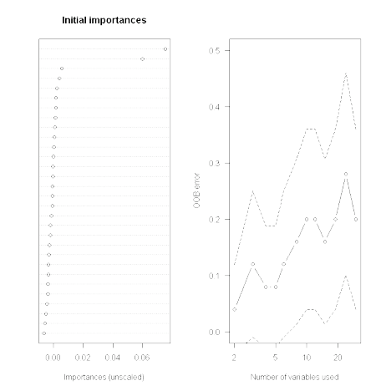
oblique.tree
This package grows an oblique decision tree (a general form of the axis-parallel tree). This example uses the crab dataset (morphological measurements on Leptograpsus crabs) available in R as a stock dataset to grow the oblique tree.
1  2  3  4  5  6  7  8  9  10  11  12 | ###############  ## OBLIQUE.TREE  library(oblique.tree)  aug.crabs.data = data.frame( g=factor(rep(1:4,each=50)),  predict(princomp(crabs[,4:8]))[,2:3])  plot(aug.crabs.data[,-1],type="n")  text( aug.crabs.data[,-1], col=as.numeric(aug.crabs.data[,1]), labels=as.numeric(aug.crabs.data[,1]))  ob.tree = oblique.tree(formula = g~.,  data = aug.crabs.data,  oblique.splits = "only")  plot(ob.tree);text(ob.tree)
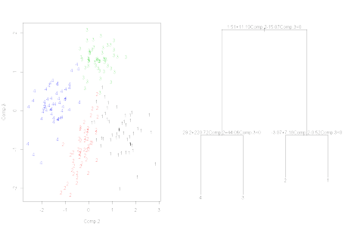
CORElearn
This is a great package that contain many different machine learning algorithms and functions. It include trees, forests, naive Bayes, locally weighted regression, among others.
1  2  3  4  5  6  7  8  9  10  11  12  13  14  15  16  17  18  19  20 | ##################  ## CORElearn  library(CORElearn)  ## Random Forests  fit.rand.forest = CoreModel(frmla, data=raw, model="rf", selectionEstimator="MDL", minNodeWeightRF=5, rfNoTrees=100)  plot(fit.rand.forest)  ## decision tree with naive Bayes in the leaves  fit.dt = CoreModel(frmla, raw, model="tree", modelType=4)  plot(fit.dt, raw)  airquality.sub = subset(airquality, !is.na(airquality$Ozone))  fit.rt = CoreModel(Ozone~., airquality.sub, model="regTree", modelTypeReg=1)  summary(fit.rt)  plot(fit.rt, airquality.sub, graphType="prototypes")  pred = predict(fit.rt, airquality.sub)  print(pred)  plot(pred)
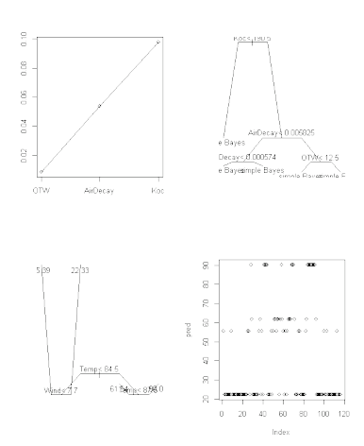
longRPart
This provides an implementation for recursive partitioning for longitudinal data. It uses the rules from rpart and the mixed effects models from nlme to grow regression trees. This can be a little resource intensive on some slower computers.
1  2  3  4  5  6  7  8 | ##################  ##longRPart  library(longRPart)  data(pbkphData)  pbkphData$Time=as.factor(pbkphData$Time)  long.tree = longRPart(pbkph~Time,~age+gender,~1|Subject,pbkphData,R=corExp(form=~time))  lrpTreePlot(long.tree, use.n=TRE, place="bottomright")
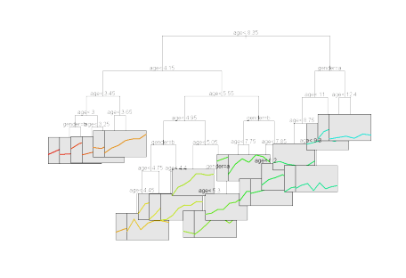
REEMtree
This package is useful for longitudinal studies where random effects exist. This example uses the pbkphData dataset available in the longRPart package.
1  2  3  4  5  6  7  8  9  10  11 | ##################  ## REEMtree Random Effects for Longitudinal Data  library(REEMtree)  pbkphData.sub = subset(pbkphData, !is.na(pbkphData$pbkph))  reem.tree = REEMtree(pbkph~Time, data=pbkphData.sub, random=~1|Subject)  plot(reem.tree)  ranef(reem.tree) #random effects  reem.tree = REEMtree(pbkph~Time, data=pbkphData.sub, random=~1|Subject,  correlation=corAR1())  plot(reem.tree)

inShare1

Related
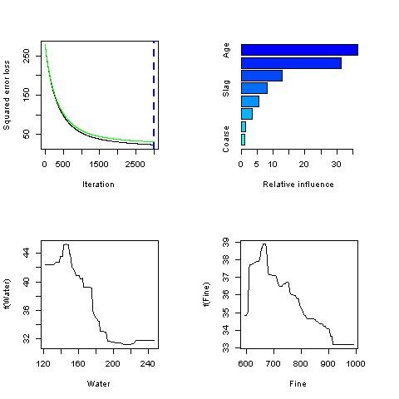

Ensemble Packages in R
In "R bloggers"
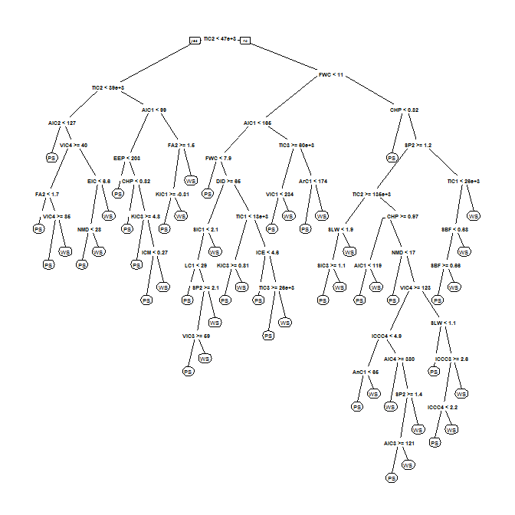

Draw nicer Classification and Regression Trees with the rpart.plot package
In "R bloggers"

rxDTree(): a new type of tree algorithm for big data
by Joseph Rickert The rxDTree() function included in the RevoScaleR package distributed with Revolution R Enterprise is an an example of a new class of algorithms that are being developed to deal with very large data sets. Although the particulars differ, what these algorithms have in common is the use…
In "R bloggers"

