實例練習2
步驟一：利用R中read.csv的語法將sleepdata.csv資料檔匯入R中，並將此檔命名為data。
R語法 | 語法解釋
>data<-read.csv("c:/RData/sleepdata.csv",header=T)  >data | data<- #是將c:\\R\\sleepdata.csv的檔案以data的名字讀取，亦可寫成data=

- 結果：
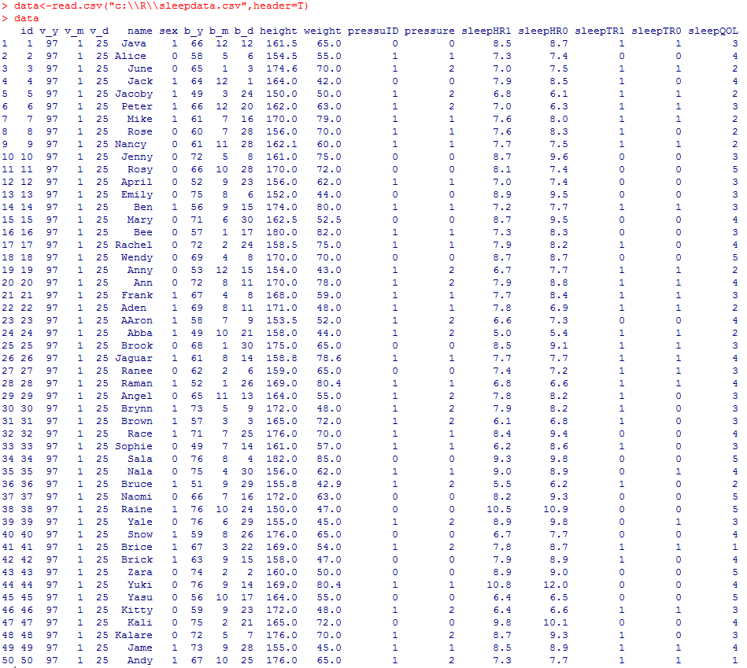

步驟二：用R中summary語法呈現描述性統計結果。
R語法 | 語法解釋
>summary(data[,c(12,13,18,19,20)]) | # Summary會顯示6個基本的描述性統計，分別為  Min. 1st Qu. Median Mean 3rd Qu. Max.  極小值 Q1 Q2 平均值 Q3 極大值

- 結果：
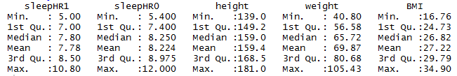

步驟三：用R中attach語法或”$”將資料中的變數名稱連結，並以summary語法觀 察各變項的描述性統計。

方法一：attach語法
R語法 | 語法解釋
>attach(data)  >summary(height) | 以height為例：  # attach將data下的所有變數視為單一物件，若以detach(data)則關閉連結

- 結果：
> attach(data)
The following object is masked _by_ .GlobalEnv:
name
The following object is masked from package:datasets:
pressure

以attach語法，會出現框框內的文字，表示已經和data連結成功，以下的語法只需輸入data內的變項名稱即可。
> summary(height)
Min. 1st Qu. Median Mean 3rd Qu. Max.
139.0 149.2 159.0 159.4 168.5 181.0

> detach(data) # 去除和data的連結
> summary(height)
Error in summary(height) : object 'height' not found

方法二
R語法 | 語法解釋
>summary(data$height) | # data$變數名稱，會搜尋data下的變數名稱。

> summary(data$height)
Min. 1st Qu. Median Mean 3rd Qu. Max.
139.0 149.2 159.0 159.4 168.5 181.0

步驟四：針對類別變數，利用table語法來建立類別變數(名目及序位變數)之描述性統計。
R語法 | 語法解釋
# 完成attach語法後  >attach(data)  >table(sex)  >table(pressuID)  >table(pressure)  >table(sleepTR1)  >table(sleepTR0)  >table(sleepQOL) | # 當x為類別變項時，建立次數分配表

- 結果：
> attach(data)
The following object is masked _by_ .GlobalEnv:
name
The following object is masked from package:datasets:
pressure

> table(sex)
sex
0 1
28 22
> table(pressuID)
pressuID
0 1
17 33
> table(pressure)
pressure
0 1 2
17 17 16
> table(sleepTR1)
sleepTR1
0 1
20 30
> table(sleepTR0)
sleepTR0
0 1
28 22
> table(sleepQOL)
sleepQOL
1 2 3 4 5
2 9 17 15 7

