# 先確定下面四個套件已經安裝並在user library有勾選
## install.packages("qqplot2", dependencies = TRUE,
## repos="http://cran.us.r-project.org")
## install.packages("formatR", dependencies = TRUE,
## repos="http://cran.us.r-project.org")
## install.packages("highlight", dependencies = TRUE,
## repos="http://cran.us.r-project.org")
## install.packages("xtable", dependencies = TRUE,
## repos="http://cran.us.r-project.org")
require(formatR)
require(highlight)
require(xtable)
require(ggplot2)
## library(formatR)
## library(highlight)
## library(xtable)
## library(ggplot)
## library(xtable)

# 設定工作目錄
setwd("C:/RData")
# 確定EXCEL檔avgpm25.csv在目錄C:/RData下
# 將EXCEL檔案讀入R, colClasses行變數的類型
pollution <- read.csv("C:/RData/avgpm25.csv",
colClasses=c("numeric", "character",
"factor","numeric", "numeric"))

# 印出空氣汙染這個data frame 的第一部分(前6筆)
head(pollution)
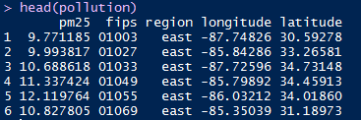
# 細懸浮微粒（PM2.5，直徑≦2.5 微米）

# 印出細懸浮微粒的5個數字的摘要(5-number summary)加平均數
# pollution$pm25 代表在data frame pollution中的pm25變數, 用$號連結
summary(pollution$pm25)
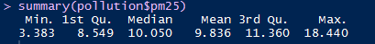

# 畫細懸浮微粒的盒狀圖, 顏色用藍色
boxplot(pollution$pm25, col = "blue")
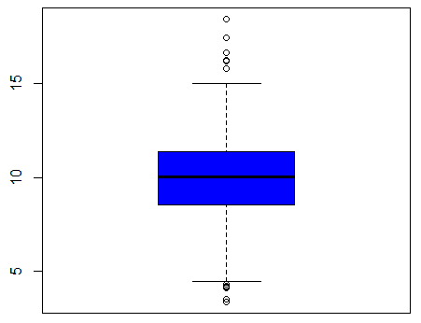
# 分配大致對稱, 有一些outliers

# 畫細懸浮微粒的直方圖, 顏色用綠色, y軸是次數
hist(pollution$pm25, col = "green")
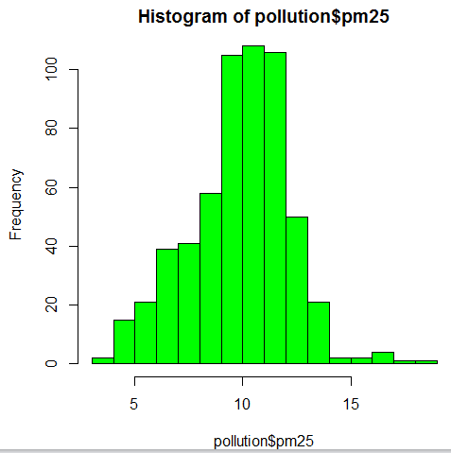
# 畫細懸浮微粒的直方圖, 顏色用綠色, y軸是次數
hist(pollution$pm25, col = "green")
rug(pollution$pm25) # 將數據加到圖下方(將數據用地毯表示)
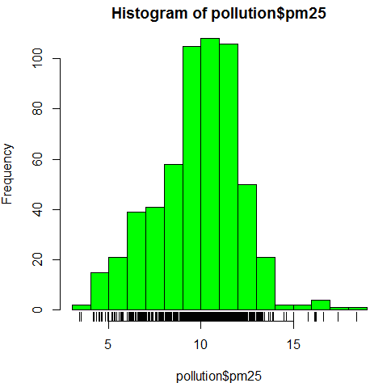

# 畫細懸浮微粒的直方圖, 顏色用綠色, y軸是次數, 分成100格
hist(pollution$pm25, col = "green", breaks = 100)
rug(pollution$pm25)
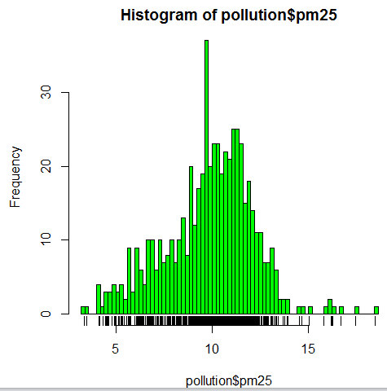
# 畫細懸浮微粒的盒狀圖, 顏色用藍色
boxplot(pollution$pm25, col = "blue")
abline(h = 12) # 在位置12加畫一條水平線
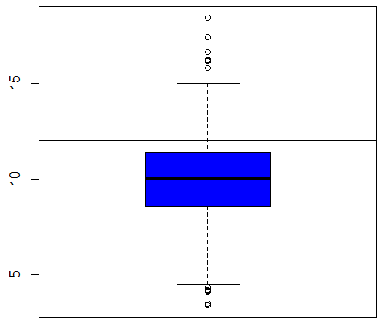

# 畫細懸浮微粒的直方圖, 顏色用綠色
hist(pollution$pm25, col = "green")
abline(v = 12, lwd = 2) # 在位置12加畫一條垂直線, 線條寬度為2
abline(v = median(pollution$pm25), col = "magenta", lwd = 4) # 在中位數位置加畫一條垂直線, 線條寬度為4, 顏色為品紅
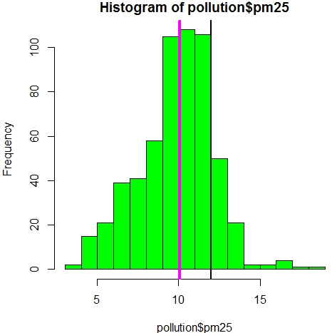
# 建立變數區域的次數分配表
table(pollution$region)
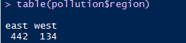

# 畫區域的次數的長條圖, 顏色是麥色, 圖標題為"Number of Counties in Each Region"
barplot(table(pollution$region), col = "wheat", main = "Number of Counties in Each Region")

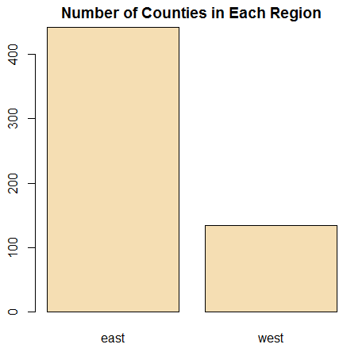

# 畫按區域分組的 細懸浮微粒的盒狀圖, 顏色用紅色
boxplot(pm25 ~ region, data = pollution, col = "red")

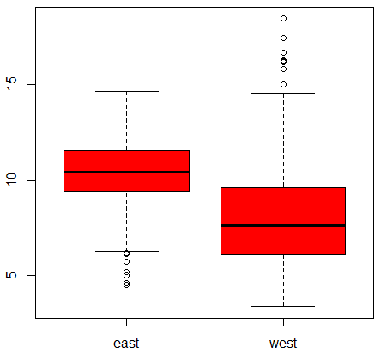

# 由圖可知空氣中的細懸浮微粒高於西區，東區空氣汙染較嚴重

# 設定繪圖參數, mfrow = c(1, 2)代表圖將放在1列2行的矩陣, mar = c(4, 4, 2, 1)代表圖的下左上右的邊寬
par(mfrow = c(1, 2), mar = c(4, 4, 2, 1))
hist(subset(pollution, region == "east")$pm25, col = "green")
hist(subset(pollution, region == "west")$pm25, col = "green")
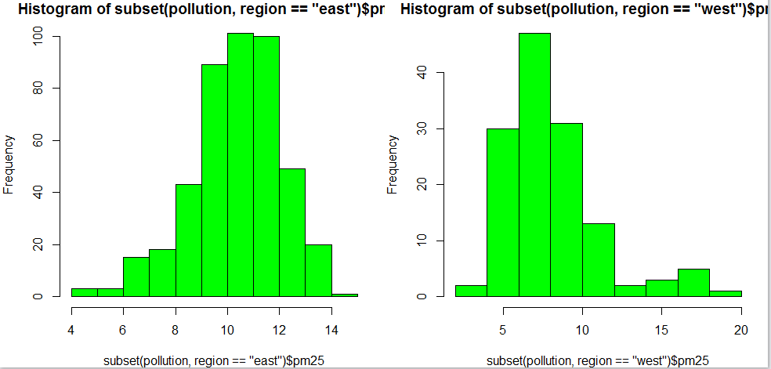
# 左邊是東區的細懸浮微粒的直方圖, 右邊是東區的細懸浮微粒的直方圖
# 左邊東區的直方圖可知細懸浮微粒的分佈大致呈現對稱, 右邊西區的直方圖可知細懸浮微粒的分佈大致呈現右偏

# 選出區域為east的細懸浮微粒的資料可利用subset指令
subset(pollution, region == "east")$pm25
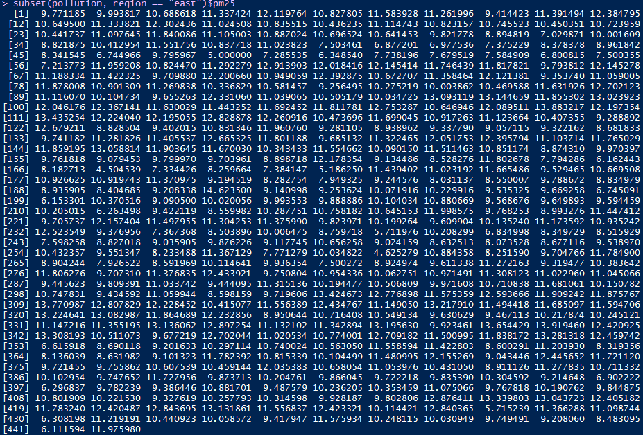

# with 是指Evaluate an Expression in a Data Environment

# 畫散佈圖, x軸是緯度, y軸是細懸浮微粒
with(pollution, plot(latitude, pm25))
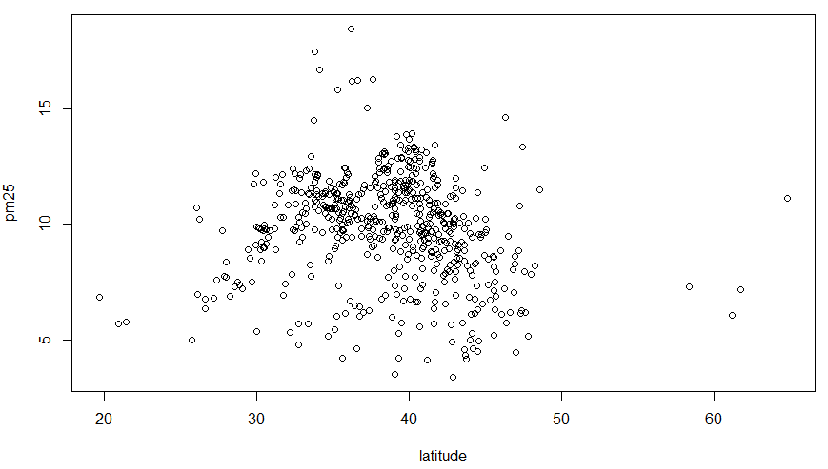
abline(h = 12, lwd = 2, lty = 2) #在位置12加畫一條水平線, 線條寬度為2, 線條類型為2, 虛線
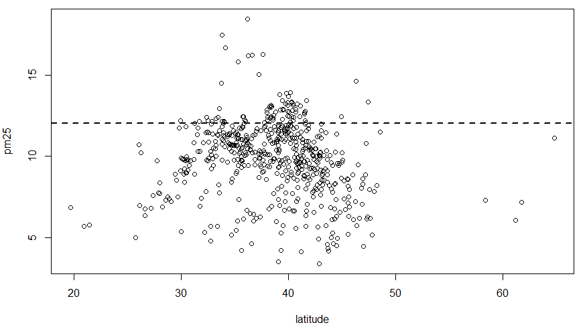

# 由散佈圖可看出緯度與細懸浮微粒沒有相關

# 畫散佈圖, x軸是緯度, y軸是細懸浮微粒, 亦可用下面指令
plot(pollution$latitude, pollution$pm25, xlab="latitude", ylab="pm25")
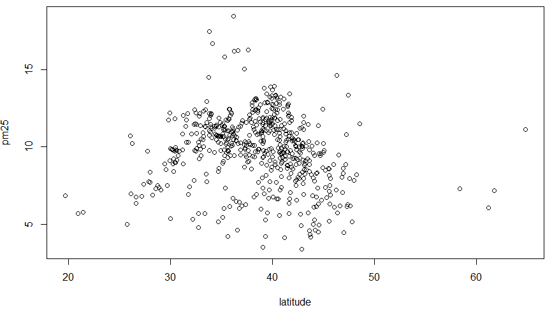

# 畫散佈圖, x軸是緯度, y軸是細懸浮微粒, 按區域分顏色, 東區是黑色, 西區是紅色
with(pollution, plot(latitude, pm25, col = region))
abline(h = 12, lwd = 2, lty = 2) #在位置12加畫一條水平線, 線條寬度為2, 線條類型為2, 虛線

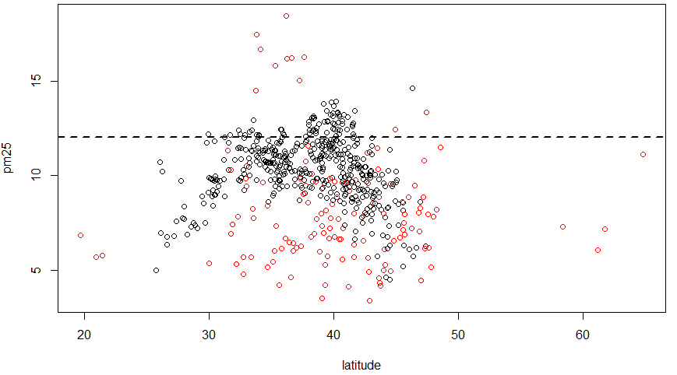
# 西區細懸浮微粒較分散, 東區細懸浮微粒較集中

# 設定繪圖參數, mfrow = c(1, 2)代表圖將放在1列2行的矩陣, mar = c(4, 4, 2, 1)代表圖的下左上右的邊寬
par(mfrow = c(1, 2), mar = c(4, 4, 2, 1))

# 畫散佈圖, 區域為西區, x軸是緯度, y軸是細懸浮微粒
with(subset(pollution, region == "west"), plot(latitude, pm25, main = "West"))

# 畫散佈圖, 區域為東區, x軸是緯度, y軸是細懸浮微粒
with(subset(pollution, region == "east"), plot(latitude, pm25, main = "East"))

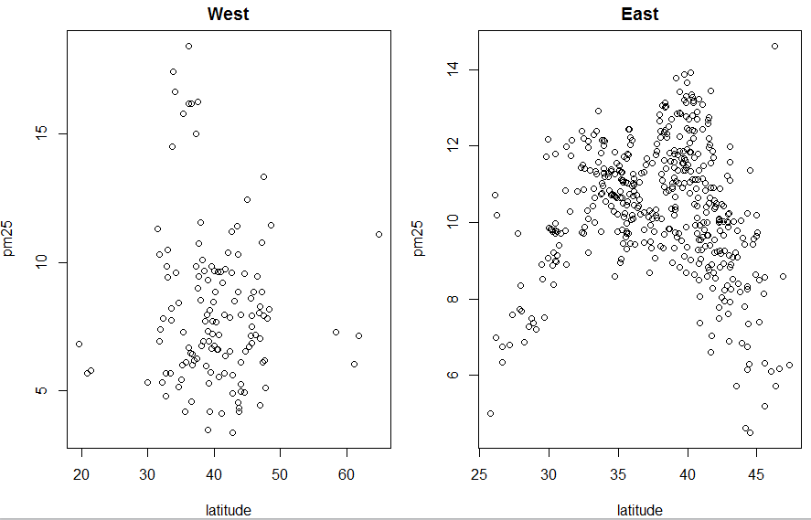
# 設定繪圖參數, mfrow = c(1, 2)代表圖將放在1列2行的矩陣, mar = c(4, 4, 2, 1)代表圖的下左上右的邊寬
par(mfrow = c(1, 2), mar = c(4, 4, 2, 1))

# 畫散佈圖, 區域為西區, x軸是緯度, y軸是細懸浮微粒, y軸範圍為1到20
with(subset(pollution, region == "west"), plot(latitude, pm25, main = "West", ylim=c(1,20)))

# 畫散佈圖, 區域為東區, x軸是緯度, y軸是細懸浮微粒, y軸範圍為1到20
with(subset(pollution, region == "east"), plot(latitude, pm25, main = "East" , ylim=c(1,20)))
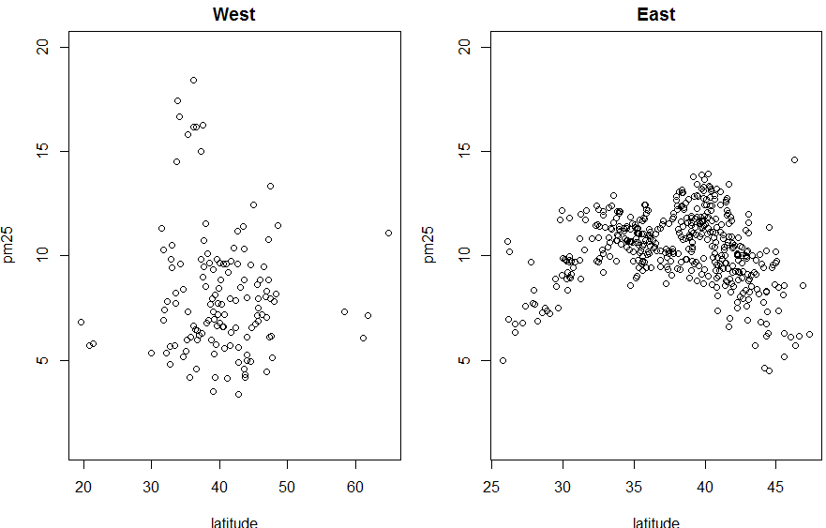
# y軸範圍一樣, 才可看出細懸浮微粒的分散程度
# 西區緯度與細懸浮微粒無關, 東區緯度與細懸浮微粒有非線性相關

